A000-Afr-Tanzania-Makonde Mask-Blackened-Late 19th century

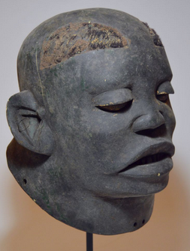 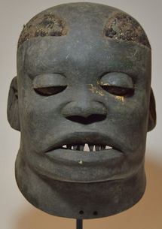 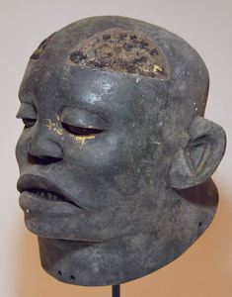 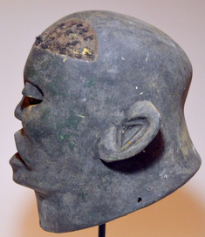 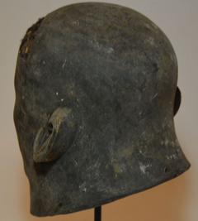

**Case No.: 6**

**Formal Label:** Makonde Mask of Tanzania, East Africa

**Accession Number:**

**Display Description:**

This is a classic Helmet mask known as *lipiko* (plural, *mapiko*) of the Makonde people, which was worn before contact was made with missionaries in the 19th century. These masks are painstakingly carved from a single block of light wood (usually 'sumaumeira brava') and may represent spirits ('shetani'), ancestors, or living characters (real or idealized initiates, villagers, coastal Arabs and colonial officials). The dancer wears them so that he sees through the mask's mouth and the mask faces straight when he bends forward. Although both male and female heads can be depicted, female heads are very rare. The *mapiko* are unusually realistic and are notable for their strong, portrait-like features: many have real human hair applied in shaved patterns, raised or incised facial scarification, open mouths with bared teeth, large ears or lip-plugs. In many cases there will be elaborate scarification on the face which was done as a part of initiation ceremonies and also when a ranking member of society assumed a more important political status or social level. Sometimes they have a lip plug, which Makonde men used to wear. It was believed that the ancestors came back in the masked dancers in order to witness the successful achievement of initiation, proof of the close bonds that exist between the living and the dead. *Mapiko* is the name given to these masks, the name of the dance embodying the ancestral spirit who performs in it, and the name given to one of the stages of male initiation -- when the initiate is introduced into the secrets of the *Mapiko*. The masks themselves are made in a secret bush location known as the Mpolo, which women are forbidden to approach. When not in use, the masks are kept in the Mpolo and were traditionally burned when broken or replaced with new masks. The Makonde successfully resisted predation by African, Arab, and European slavers until they came under German colonial domination in the 1920s. During the 1960s the revolution which drove the Portuguese out of Mozambique was launched from the Makonde homeland of the Mueda Plateau.

**LC Classification:** NB1310

**Date or Time Horizon:** early 20th century

**Geographical Area:** Tanzania

**Cultural Affiliation:** Makonde. The Makonde are an ethnic group in southeast Tanzania and northern Mozambique. The Makonde developed their culture on the Mueda Plateau in Mozambique. At present they live throughout Tanzania and Mozambique and have a small presence in Kenya.

**Medium:** “black wood,” *Dalbergia melanoxylon* or mpingo, charcoal pigment, and black fiber for hair patches.

**Dimensions: H 11 in, W 8 in  
Weight:**

**Provenance:**

**Condition: some aging from use in village play acts.**

**Discussion:**

The Makonde have their own Bantu language and they originated on the Mueda Plateau in Mozambique. When some migrated to Tanzania the Ruvuma River divides those in Tanzania (the Makonde) and those in Mozambique (the Maconde). In both regions their indigenous religion centers on ancestor worship (despite the inroads of Islam and Catholicism) and their masks emulate deceased members of their extended family groups. Those involved in play-acting of the deceased develop scripts that engender the main attributes of those who have passed on as a device for others to emulate, especially in their elaborate puberty rites.

**References:**

Fagg, William Buller. 1980. Makonde. In Masques d'Afrique dans les collections du Musée Barbier-Müller. pages 154-155. Geneva: Editions Fernand Nathan.

Masques d'Afrique dans les collections du Musée Barbier-Müller. 1980. Geneva : Editions Fernand Nathan.

Spence, Karen Ilene. 1983. *Typology and functions of the masks of the Makonde  
of Tanzania and Mozambique*. M.A. Thesis. Los Angeles: University of California.

Stoner, John. 1998. Makonde. New York: The Rosen Publishing Group.